Ting Hu

**From:** Ting Hu  
**Sent:** Monday, 01 June 2025 10:44 PM  
**To:** Vinh Nguyen

**Cc:** Sam Rice  
**Subject:** Sample Email Template

Dear Sam Rice and Vinh Nguyen:

Please find attached our recommendation for the client -Special Cakes for All Occasions website.

If you require more information, please contact us.

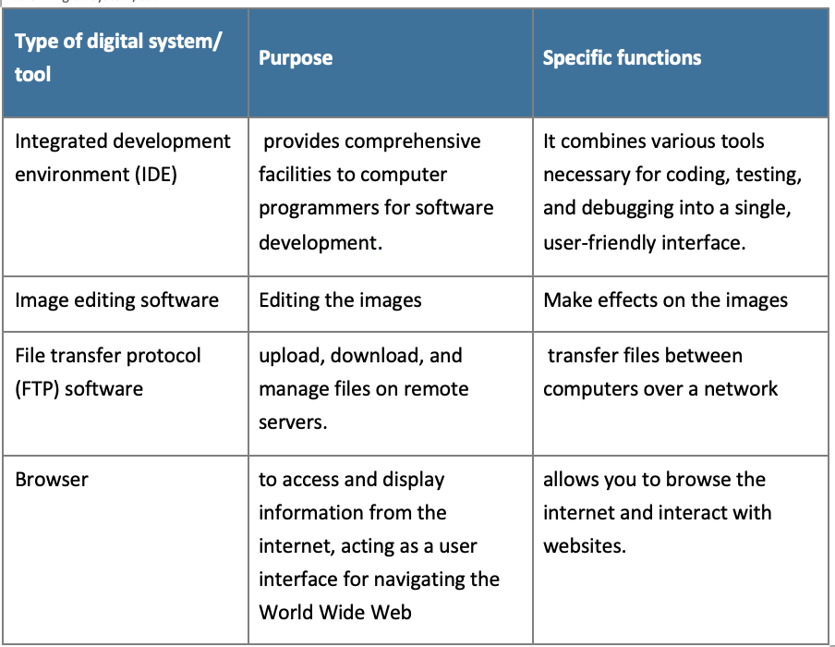

Kind regards

Ting Hu

**Web developer**  
e: Ting.Hu@gelosmail.com.au  
m: 0491 000 000

111 Business Avenue

TULITZA NSW 9460

p: 02 0000 0000

e: [contactus@gelosmail.com.au](mailto:contactus@gelosmail.com.au)

Save a tree. Please do not print this email unless you really need to.

This message, including any attachments, is intended for the individual to whom it is addressed. It may contain privileged or confidential information. If you are not the intended recipient, please delete it and notify the sender. You must not disclose, copy or use the information in this message.